Recursion – In class exercises
We’re going to have some fun with fractals and graphics. You will need to download a .jar file and install. I am assuming folks are using Eclipse.

You are going to need a file called acm.jar . You can download it here:
http://cs.stanford.edu/people/eroberts/jtf/

Scroll down the page to find the correct link. Remember , when you download a file, it goes in your “Download” directory. You may wish to copy it to a more convenient place (like the Desktop). You will then need to copy the file into your project directory and update the classPath. I will demo in class, but you may wish to look at:
http://www.wikihow.com/Add-JARs-to-Project-Build-Paths-in-Eclipse-%28Java%29

Assignment 1)
Execute the code on the following page (class Sierpinski). What happens if you comment out the first “drawGasket” inside the if-statement? The second one? Experiment commenting others out. Go back to original program and change every occurrence of GRect to GOval. Run this program.

Big Extra Credit: Write a java program to create the following:

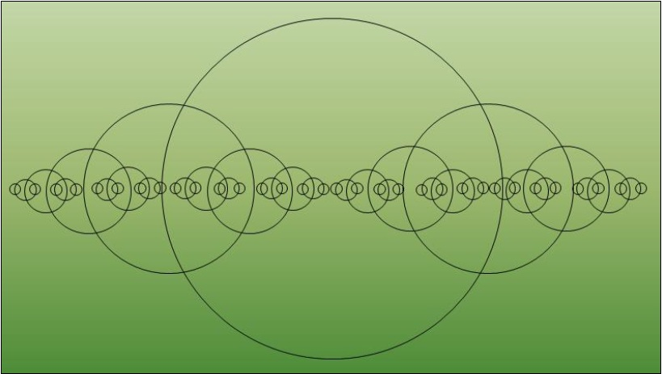

Assignment 2)
Execute the code on page 3. Experiment with different values .

Assignment Number 1)

import java.awt.*;
import acm.program.*;
import acm.graphics.*;

public class Sierpinski extends GraphicsProgram {
public void run() {
// draw black background square
GRect box = new GRect(20, 20, 500, 500);
box.setFilled(true);
add(box);

// recursively draw all the white squares on top
drawGasket(20, 20, 501);
}

public void drawGasket(int x, int y, int side) {
// draw single white square in middle
int sub = side / 3; // length of sub-squares
GRect box = new GRect(x+sub,y+sub, sub - 1, sub - 1);
box.setFilled(true);
box.setColor(Color.WHITE);
add(box);

if(sub >= 3) {
// now draw eight sub-gaskets around the white square
drawGasket(x, y, sub);
drawGasket(x + sub, y, sub);
drawGasket(x + 2 * sub, y, sub);
drawGasket(x, y + sub, sub);
drawGasket(x + 2 * sub, y + sub, sub);
drawGasket(x, y + 2 * sub, sub);
drawGasket(x + sub, y + 2 * sub, sub);
drawGasket(x + 2 * sub, y + 2 * sub, sub);
}
}
}

Assignment 2)

import java.awt.*;
import acm.program.*;
import acm.graphics.*;

public class Tree extends GraphicsProgram {
public void run() {

drawTree(240, 400, 100, 90);
}

public void drawTree(double x0, double y0, double len, double angle) {
if(len > 2) {
double x1 = x0 + len * GMath.cosDegrees(angle);
double y1 = y0 - len * GMath.sinDegrees(angle);

add(new GLine(x0, y0, x1, y1));
drawTree(x1, y1, len * 0.75, angle + 60);
drawTree(x1, y1, len * 0.60, angle - 40);
}
}
}

